**Working with Objects**

*EPANET uses various types of objects to model a distribution system. These objects can be accessed either directly on the network map or from the Data page of the Browser window. This chapter describes what these objects are and how they can be created, selected, edited, deleted, and repositioned.*

**Types of Objects:**

EPANET contains both physical objects that can appear on the network map, and non-physical objects that encompass design and operational information. These objects can be classified as followed:

1. Nodes
   1. Junctions
   2. Reservoirs
   3. Tanks
2. Links
   1. Pipes
   2. Pumps
   3. Valves
3. Map Labels
4. Time Patterns
5. Curves
6. Controls
   1. Simple
   2. Rule-Based

## **Adding Objects:**

## **Adding a Node:**

1. Click the button for the type of node (junction image78, reservoir image79, or tank image80) to add from the Map Toolbar.
2. Move the mouse to the desired location on the map and click.

**Adding a Link:**

1. Click the button for the type of link to add (pipe image82, pump image83, or valve image84 ) from the Map Toolbar.
2. On the map, click the mouse over the link’s start node.
3. Move the mouse in the direction of the link’s end node, clicking it at those intermediate points where it is necessary to change the link’s direction.
4. Click the mouse a final time over the link’s end node.

Pressing the right mouse button or the Escape key while drawing a link will cancel the operation.

**Adding a Map Label:**

1. Click the Text button image85 on the Map Toolbar.
2. Click the mouse on the map where label should appear.
3. Enter the text for the label.
4. Press the **Enter** key.

**Adding a Curve:**

1. Select Curve from the object category list of the Data Browser.
2. Click the Add button.
3. Edit the curve using the Curve Editor.

**Adding a Time Pattern:**

1. Select Patterns from the object category list of the Data Browser.
2. Click the Add button.
3. Edit the pattern using the Pattern Editor.

**Using a Text File:**

In addition to adding individual objects interactively, you can import a text file containing a list of node ID’s with their coordinates as well as a list of link ID’s and their connecting nodes.

## **Selecting Objects:**

## Make sure that the map is in Selection mode (the mouse cursor has the shape of an arrow pointing up to the left). To switch to this mode, either click the Select Object button image86 on the Map Toolbar or choose **Select Object** from the **Edit** menu.

## Click the mouse over the desired object on the map.

## **Editing Visual Objects:**

The Property Editor is used to edit the properties of objects that can appear on the Network Map (Junctions, Reservoirs, Tanks, Pipes, Pumps, Valves, or Labels). To edit one of these objects, select the object on the map.

**The Junction Properties**

|  |  |
| --- | --- |
| **PROPERTY** | **DESCRIPTION** |
| Junction ID | A unique label used to identify the junction. It can consist of a combination of up to 15 numerals or characters. It cannot be the same as the ID for any other node. This is a required property. |
| X-Coordinate | The horizontal location of the junction on the map, measured in the map’s distance units. If left blank the junction will not appear on the network map. |
| Y-Coordinate | The vertical location of the junction on the map, measured in the map’s distance units. If left blank the junction will not appear on the network map. |
| Description | An optional text string that describes other significant information about the junction. |
| Tag | An optional text string (with no spaces) used to assign the junction to a category, such as a pressure zone. |
| Elevation | The elevation in feet (meters) above some common reference of the junction. This is a required property. |
| Base Demand | The average or nominal demand for water by the main category of consumer at the junction, as measured in the current flow units. A negative value is used to indicate an external source of flow into the junction. If left blank then demand is assumed to be zero. |
| Demand Pattern | The ID label of the time pattern used to characterize time variation in demand for the main category of consumer at the junction. The pattern provides multipliers that are applied to the Base Demand to determine actual demand in a given time period. If left blank then the **Default Time Pattern** assigned in the Hydraulic Options will be used |
| Demand Categories | Number of different categories of water users defined for the junction. Click the ellipsis button (or hit the Enter key) to bring up a special Demands Editor which will let you assign base demands and time patterns to multiple categories of users at the junction. Ignore if only a single demand category will suffice |
| Emitter Coefficient | Discharge coefficient for emitter (sprinkler or nozzle) placed at junction. The coefficient represents the flow (in current flow units) that occurs at a pressure drop of 1 psi (or meter). Leave blank if no emitter is present. |
| Initial Quality | Water quality level at the junction at the start of the simulation period. Can be left blank if no water quality analysis is being made or if the level is zero. |
| Source Quality | Quality of any water entering the network at this location. Click the ellipsis button to bring up the Source Quality Editor |

**The Reservoir Properties**

|  |  |
| --- | --- |
| **PROPERTY** | **DESCRIPTION** |
| Reservoir ID | A unique label used to identify the reservoir. It can consist of a combination of up to 15 numerals or characters. It cannot be the same as the ID for any other node. This is a required property. |
| X-Coordinate | The horizontal location of the reservoir on the map, measured in the map’s distance units. If left blank the reservoir will not appear on the network map. |
| Y-Coordinate | The vertical location of the reservoir on the map, measured in the map’s distance units. If left blank the reservoir will not appear on the network map. |
| Description | An optional text string that describes other significant information about the reservoir. |
| Tag | An optional text string (with no spaces) used to assign the reservoir to a category, such as a pressure zone |
| Total Head | The hydraulic head (elevation + pressure head) of water in the reservoir in feet (meters). This is a required property. |
| Head Pattern | The ID label of a time pattern used to model time variation in the reservoir’s head. Leave blank if none applies. This property is useful if the reservoir represents a tie-in to another system whose pressure varies with time. |
| Initial Quality | Water quality level at the reservoir. Can be left blank if no water quality analysis is being made or if the level is zero. |
| Source Quality | Quality of any water entering the network at this location. Click the ellipsis button to bring up the Source Quality Editor. |

**The Tank Properties**

|  |  |
| --- | --- |
| **PROPERTY** | **DESCRIPTION** |
| Tank ID | A unique label used to identify the tank. It can consist of a combination of up to 15 numerals or characters. It cannot be the same as the ID for any other node. This is a required property. |
| X-Coordinate | The horizontal location of the tank on the map, measured in the map’s scaling units. If left blank the tank will not appear on the network map. |
| Y-Coordinate | The vertical location of the tank on the map, measured in the map’s scaling units. If left blank the tank will not appear on the network map. |
| Description | Optional text string that describes other significant information about the tank. |
| Tag | Optional text string (with no spaces) used to assign the tank to a category, such as a pressure zone |
| Elevation | Elevation above a common datum in feet (meters) of the bottom shell of the tank. This is a required property. |
| Initial Level | Height in feet (meters) of the water surface above the bottom elevation of the tank at the start of the simulation. This is a required property. |
| Minimum Level | Minimum height in feet (meters) of the water surface above the bottom elevation that will be maintained. The tank will not be allowed to drop below this level. This is a required property. |
| Maximum Level | Maximum height in feet (meters) of the water surface above the bottom elevation that will be maintained. The tank will not be allowed to rise above this level. This is a required property. |
| Diameter | The diameter of the tank in feet (meters). For cylindrical tanks this is the actual diameter. For square or rectangular tanks, it can be an equivalent diameter equal to 1.128 times the square root of the cross-sectional area. For tanks whose geometry will be described by a curve it can be set to any value. This is a required property. |
| Minimum Volume | The volume of water in the tank when it is at its minimum level, in cubic feet (cubic meters). This is an optional property, useful mainly for describing the bottom geometry of non-cylindrical tanks where a full volume versus depth curve will not be supplied |
| Volume Curve | The ID label of a curve used to describe the relation between tank volume and water level. If no value is supplied then the tank is assumed to be cylindrical. |
| Mixing Model | The type of water quality mixing that occurs within the tank |
| Mixing Fraction | The fraction of the tank’s total volume that comprises the inlet-outlet compartment of the two-compartment (2COMP) mixing model. Can be left blank if another type of mixing model is employed. |
| Reaction Coefficient | The bulk reaction coefficient for chemical reactions in the tank. |
| Initial Quality | Water quality level in the tank at the start of the simulation. Can be left blank if no water quality analysis is being made or if the level is zero. |
| Source Quality | Quality of any water entering the network at this location. Click the ellipsis button to bring up the Source Quality Editor |

**The Pipe Properties**

|  |  |
| --- | --- |
| **PROPERTY** | **DESCRIPTION** |
| Pipe ID | A unique label used to identify the pipe. It can consist of a combination of up to 15 numerals or characters. It cannot be the same as the ID for any other link. This is a required property. |
| Start Node | The ID of the node where the pipe begins. This is a required property. |
| End Node | The ID of the node where the pipe ends. This is a required property. |
| Description | An optional text string that describes other significant information about the pipe. |
| Tag | An optional text string (with no spaces) used to assign the pipe to a category, perhaps one based on age or material |
| Length | The actual length of the pipe in feet (meters). This is a required property. |
| Diameter | The pipe diameter in inches (mm). This is a required property. |
| Roughness | The roughness coefficient of the pipe. This is a required property. |
| Loss Coefficient | Unitless minor loss coefficient associated with bends, fittings, etc. Assumed 0 if left blank. |
| Initial Status | Determines whether the pipe is initially open, closed, or contains a check valve. If a check valve is specified then the flow direction in the pipe will always be from the Start node to the End node. |
| Bulk Coefficient | The bulk reaction coefficient for the pipe |
| Wall Coefficient | The wall reaction coefficient for the pipe |

**The Pump Properties**

|  |  |
| --- | --- |
| **PROPERTY** | **DESCRIPTION** |
| Pump ID | A unique label used to identify the pump. It can consist of a combination of up to 15 numerals or characters. It cannot be the same as the ID for any other link. This is a required property. |
| Start Node | The ID of the node on the suction side of the pump. This is a required property |
| End Node | The ID of the node on the discharge side of the pump. This is a required property |
| Description | An optional text string that describes other significant information about the pump. |
| Tag | An optional text string (with no spaces) used to assign the pump to a category, perhaps based on age, size or location |
| Pump Curve | The ID label of the pump curve used to describe the relationship between the head delivered by the pump and the flow through the pump. Leave blank if the pump will be a constant energy pump. |
| Power | The power supplied by the pump in horsepower (kw). Assumes that the pump supplies the same amount of energy no matter what the flow is. Leave blank if a pump curve will be used instead. |
| Speed | The relative speed setting of the pump (unitless). For example, a speed setting of 1.2 implies that the rotational speed of the pump is 20% higher than the normal setting. |
| Pattern | The ID label of a time pattern used to control the pump’s operation. The multipliers of the pattern are equivalent to speed settings. A multiplier of zero implies that the pump will be shut off during the corresponding time period. Leave blank if not applicable. |
| Initial Status | State of the pump (open or closed) at the start of the simulation period. |
| Efficiency Curve | The ID label of the curve that represents the pump’s wire-to-water efficiency (in percent) as a function of flow rate. This information is used only to compute energy usage. Leave blank if not applicable. |
| Energy Price | The average or nominal price of energy in monetary units per kw-hr. Used only for computing the cost of energy usage. Leave blank if not applicable. |
| Price Pattern | The ID label of the time pattern used to describe the variation in energy price throughout the day. Each multiplier in the pattern is applied to the pump’s Energy Price to determine a time-of-day pricing for the corresponding period. Leave blank if not applicable. |

**The Valve Properties:**

|  |  |
| --- | --- |
| **PROPERTY** | **DESCRIPTION** |
| ID Label | A unique label used to identify the valve. It can consist of a combination of up to 15 numerals or characters. It cannot be the same as the ID for any other link. This is a required property. |
| Start Node | The ID of the node on the nominal upstream or inflow side of the valve. This is a required property. |
| End Node | The ID of the node on the nominal downstream or discharge side of the valve. This is a required property. |
| Description | An optional text string that describes other significant information about the valve. |
| Tag | An optional text string (with no spaces) used to assign the valve to a category, perhaps based on type or location. |
| Diameter | The valve diameter in inches (mm). This is a required property. |
| Type | The valve types (PRV, PSV, PBV, FCV, TCV, or GPV). This is a required property. |
| Setting | A required parameter for each valve type that describes its operational setting: PRV, PSV, PBV - Pressure (psi or m) FCV - Flow (flow units) TCV - Loss Coeff (unitless) GPV - ID of head loss curve |
| Loss Coefficient | Unitless minor loss coefficient that applies when the valve is completely opened. Assumed 0 if left blank. |
| Fixed Status | Valve status at the start of the simulation. |

**The Map Label Properties**

|  |  |
| --- | --- |
| **PROPERTY** | **DESCRIPTION** |
| Text | The label’s text. |
| X-Coordinate | The horizontal location of the upper left corner of the label on the map, measured in the map’s scaling units. This is a required property. |
| Y-Coordinate | The vertical location of the upper left corner of the label on the map, measured in the map’s scaling units. This is a required property. |
| Anchor Node | ID of node that serves as the label’s anchor point. Leave blank if label will not be anchored. |
| Meter Type | Type of object being metered by the label. Choices are None, Node, or Link. |
| Meter ID | ID of the object (Node or Link) being metered. |
| Font | Launches a Font dialog that allows selection of the label’s font, size, and style. |

A label’s anchor node property is used to anchor the label relative to a given location on the map. This feature prevents labels from wandering too far away from the objects they were meant to describe when a map is zoomed.

The Meter Type and ID properties determine if the label will act as a meter. Meter labels display the value of the current viewing parameter (chosen from the Map Browser) underneath the label text. The Meter Type and ID must refer to an existing node or link in the network. Otherwise, only the label text appears.

## **Editing Non-Visual Objects:**

Curves, Time Patterns, and Controls have special editors that are used to define their properties. To edit one of these objects, select the object from the Data Browser and then click the Edit button image88. In addition, the Property Editor for Junctions contains an ellipsis button in the field for Demand Categories that brings up a special Demand Editor when clicked. Similarly, the Source Quality field in the Property Editor for Junctions, Reservoirs, and Tanks has a button that launches a special Source Quality editor.

**Curve Editor:**

To use the Curve Editor, enter values for the following items:

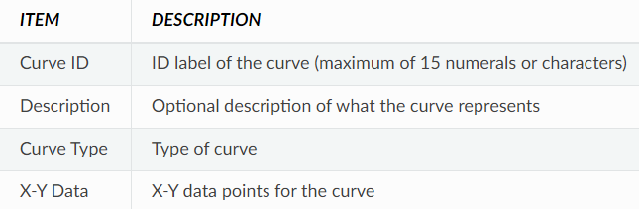

As you move between cells in the X-Y data table (or press the Enter key) the curve is redrawn in the preview window. For single- and three-point pump curves, the equation generated for the curve will be displayed in the Equation box. Click the **OK** button to accept the curve or the **Cancel** button to cancel your entries. You can also click the **Load** button to load in curve data that was previously saved to file or click the **Save** button to save the current curve’s data to a file.

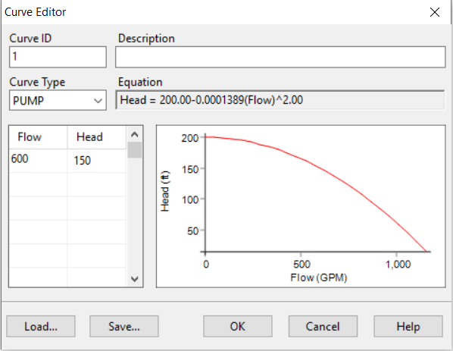

**Pattern Editor:**

To use the Pattern Editor, enter values for the following items:

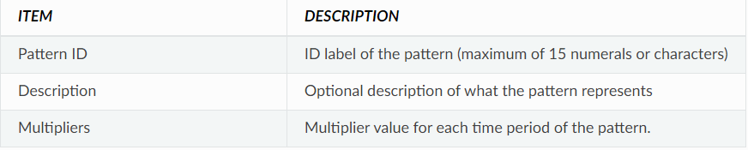

As multipliers are entered, the preview chart is redrawn to provide a visual depiction of the pattern. If you reach the end of the available Time Periods when entering multipliers, simply hit the **Enter** key to add on another period. When finished editing, click the **OK** button to accept the pattern or the **Cancel** button to cancel your entries. You can also click the **Load** button to load in pattern data that was previously saved to file or click the **Save** button to save the current pattern’s data to a file.

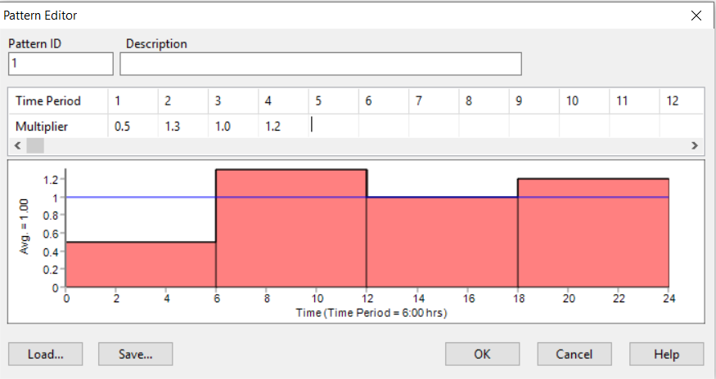

**Controls Editor:**

The Controls Editor is a text editor window used to edit both simple and rule-based controls. It has a standard text-editing menu that is activated by right-clicking anywhere in the Editor. The menu contains commands for Undo, Cut, Copy, Paste, Delete, and Select All.

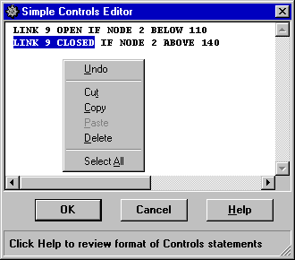

**Demand Editor:**

The Demand Editor is used to assign base demands and time patterns when there is more than one category of water user at a junction. The editor is invoked from the Property Editor by clicking the ellipsis button when the Demand Categories field has the focus. The editor is a table containing three columns. Each category of demand is entered as a new row in the table. The columns contain the following information:

* **Base Demand**: baseline or average demand for the category (required)
* **Time Pattern**: ID label of time pattern used to allow demand to vary with time (optional)
* **Category**: text label used to identify the demand category (optional)

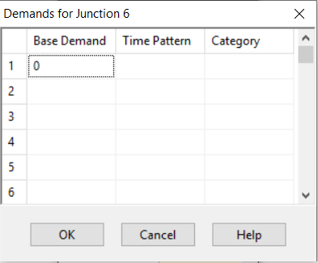

**Source Quality Editor:**

The Source Quality Editor is a pop-up dialog used to describe the quality of source flow entering the network at a specific node. This source might represent the main treatment works, a well head or satellite treatment facility, or an unwanted contaminant intrusion.

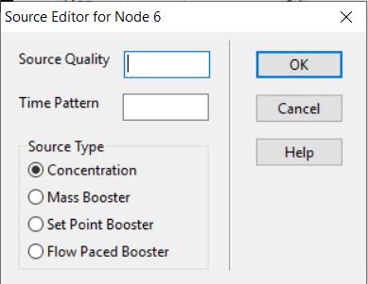

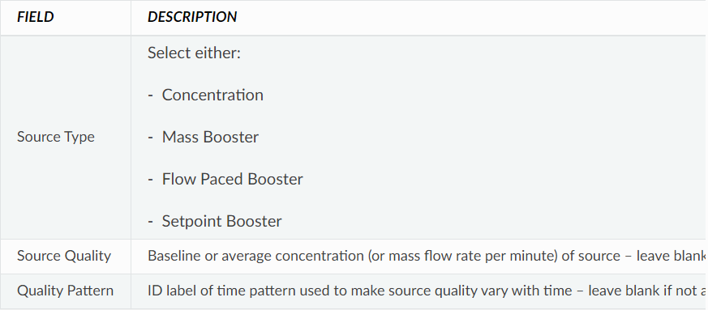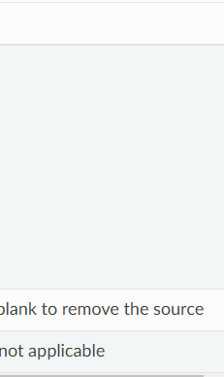

A water quality source can be designated as a concentration or booster source.

* A **concentration source** fixes the concentration of any external inflow entering the network, such as flow from a reservoir or from a negative demand placed at a junction.
* A **mass booster source** adds a fixed mass flow to that entering the node from other points in the network.
* A **flow paced booster source** adds a fixed concentration to that resulting from the mixing of all inflow to the node from other points in the network.
* A **setpoint booster source** fixes the concentration of any flow leaving the node (as long as the concentration resulting from all inflow to the node is below the setpoint).

## **Copying and Pasting Objects:**

The properties of an object displayed on the Network Map can be copied and pasted into another object from the same category. To copy the properties of an object to EPANET’s internal clipboard:

1. Right-click the object on the map.
2. Select Copy from the pop-up menu that appears.

To paste copied properties into an object:

1. Right-click the object on the map.
2. Select Paste from the pop-up menu that appears.

## **Shaping and Reversing Links:**

Links can be drawn as polylines containing any number of straight-line segments that add change of direction and curvature to the link. Once a link has been drawn on the map, interior points that define these line segments can be added, deleted, and moved. To edit the interior points of a link:

1. Select the link to edit on the Network Map and click image94 on the Map Toolbar.
2. The mouse pointer will change shape to an arrow tip, and any existing vertex points on the link will be displayed with small handles around them. To select a particular vertex, click the mouse over it.
3. To add a new vertex to the link, right-click the mouse and select **Add Vertex** from the popup menu.
4. To delete the currently selected vertex, right-click the mouse and select **Delete Vertex** from the popup menu.
5. To move a vertex to another location, drag it with the left mouse button held down to its new position.
6. While in Vertex Selection mode you can begin editing the vertices for another link by clicking on the link. To leave Vertex Selection mode, right-click on the map and select **Quit Editing** from the popup menu.

A link can also have its direction reversed (i.e., its end nodes switched) by right- clicking on it and selecting **Reverse** from the pop-up menu that appears. This is useful for re-orienting pumps and valves that originally were added in the wrong direction.

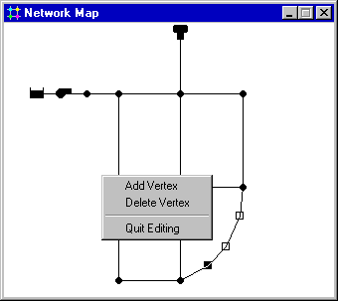

## **Deleting an Object:**

To delete an object:

1. Select the object on the map or from the Data Browser.
2. Either:
   * Click image96 on the Standard Toolbar
   * Click the same button on the Data Browser
   * Press the **Delete** key on the keyboard

## **Moving an Object:**

To move a node or label to another location on the map:

1. Select the node or label.
2. With the left mouse button held down over the object, drag it to its new location.
3. Release the left button.

Alternatively, new X and Y coordinates for the object can be typed in manually in the Property Editor. Whenever a node is moved all links connected to it are moved as well.

## **Selecting a Group of Objects:**

To select a group of objects that lie within an irregular region of the network map:

1. Select **Edit >> Select Region** or click image97 on the Map Toolbar.
2. Draw a polygon fence line around the region of interest on the map by clicking the left mouse button at each successive vertex of the polygon.
3. Close the polygon by clicking the right button or by pressing the **Enter** key; Cancel the selection by pressing the **Escape** key.

To select all objects currently in view on the map select **Edit >> Select All**. (Objects outside the current viewing extent of the map are not selected.)

## **Editing a Group of Objects:**

To edit a property for a group of objects:

1. Select the region of the map that will contain the group of objects to be edited using the method described in previous section.
2. Select **Edit >> Group Edit** from the Menu Bar.
3. Define what to edit in the Group Edit dialog form that appears.

The Group Edit dialog form, shown in [Fig. 6.7](https://epanet22.readthedocs.io/en/latest/6_objects.html#fig-group-ed-dialog), is used to modify a property for a selected group of objects. To use the dialog form:

1. Select a category of object (Junctions or Pipes) to edit.
2. Check the “with” box if you want to add a filter that will limit the objects selected for editing. Select a property, relation and value that define the filter. An example might be “with Diameter below 12”.
3. Select the type of change to make - Replace, Multiply, or Add To.
4. Select the property to change.
5. Enter the value that should replace, multiply, or be added to the existing value.
6. Click **OK** to execute the group edit.

